Anne Cummings
Educator as Artist – GED 675A
Saint Michael’s College – Summer 2016
Proposal for Concentration
My work over the past several years has revolved around my effort as an artist to explore alternatives to the use of traditional art materials, as well as to create pieces that communicate messages about environmental issues in engaging ways to viewers.
I believe that many artists and art educators are unaware of the potential toxicity, environmental impact, and unsustainable production methods of the materials generally accepted as “art supplies.” As an art educator, I am often appalled at the amount of waste that is generated in my classroom alone, and as an artist, it is easy to see the waste accumulate in the studio, despite the best attempts at conscientious recycling practices. Many art materials, such as acrylics, palettes, brushes, and much more, are made from petroleum-sourced plastics and are often difficult to recycle or reclaim after use, or were intended to be disposable from the outset.
I am trying in both my practices - as an art educator and as an artist - to work with a new awareness of this issue, and to make choices in supply purchases, recycling/repurposing efforts, and educating myself and my students about safety and environmental factors in the use of materials.
The citations below are a sampling of online resources on this issue:
Education Week: Despite Law, Many Art Supplies Lack Labels on Toxicity, Study Finds http://www.edweek.org/ew/articles/1991/09/18/03art.h11.html

Green American: Are Art Supplies Toxic? http://www.greenamerica.org/livinggreen/toxicart.cfm

Buying Safer Art Supplies

http://www.hazwastehelp.org/health/artsupplies.aspx

Terracycle – an online company which recycles ALL materials.

Methods for Disposing of Acrylic Paint Waste Water: http://www.artistsworkshopinc.com/uploads/4/3/9/5/4395932/environmental.pdf

http://blog.mosaicartsupply.com/how-to-dispose-of-acrylic-paint-rinse-water/

There are many artists who are addressing this environmental ethic in their work, often referred to as “eco-art,” through working with repurposed and recycled materials and/or creating work that communicates messages about environmental issues. A few of the more active communities of eco-artists are:

Green Museum

http://greenmuseum.org/

Women Environmental Artists Directory

http://weadartists.org/artist/annecummings

Recology Artist-In-Residence Program http://www.sfrecycling.com/index.php/about-air

In teaching Photography at Colchester High School, I often reference photographers who use their images to document social issues and causes, and have become very enamored of two photographers who do this in their work – Edward Burtynsky and Chris Jordan.

Edward Burtynsky’s images capture the devastating effects of human activities on the environment, but appear to be beautiful compositions of natural areas at first glance. The beauty belies the ugly source. I believe my work springs from a similar motivation.

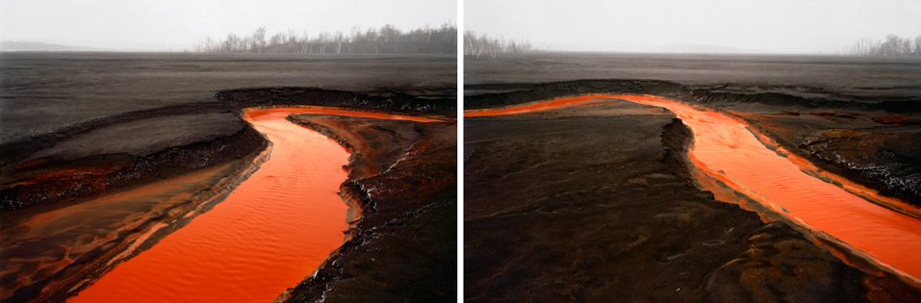
Nickel Tailings #34 & 35 Sudbury, Ontario, Canada, 1996 http://www.edwardburtynsky.com/

Chris Jordan uses his photographic images to impart information about the amount of waste generated by humans, and recently has undertaken a project to call attention to the plight of wildlife on Midway Island and in its vicinity due to the floating detritus in the Pacific known as the “plastic ocean” or “Pacific gyre.” The resources below detail the impact on the bird populations, especially the albatross, who feed plastic items from the gyre to their young thinking it is food, which kills approximately 1/3 of the fledglings.

Pacific Gyre – “Plastic Ocean” http://www.mnn.com/earth-matters/translating-uncle-sam/stories/what-is-the-great-pacific-ocean-garbage-patch

The Pacific Gyre and the Midway Atoll

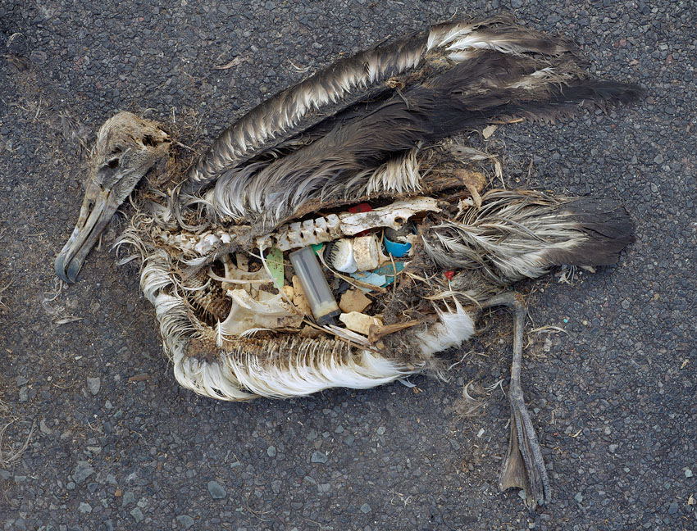

Midway: Message from the Gyre (2009 - Current) http://chrisjordan.com/gallery/midway/#CF000313%2018x24

For my concentration, I propose to do a series of works using almost exclusively recycled and repurposed materials, based on images representing the earth and the ways humans have impacted it, using simplified, symbolic, and abstract imagery. It is a departure for me to work in a less representational way, yet attempt to convey a concise understandable message. I recently did a series of very abstract paintings, which surprised me in the end with the direction they took, and the loose, free quality of the images, with interpretation left to the viewer. But for this series, I’d like to approach the work as a hybrid of the two. Not quite as loose as my abstract series, but more controlled in the attempt to impart a symbolic message based on my environmental ethos and convictions, and the inspiration drawn from the works of Burtynsky and Jordan.

